Software Requirements Specification

Table of Contents

1. Introduction 1
1.1 Purpose 1
1.2 Scope 1
1.3 References 1
1.4 Overview 1
2. General Description 1
2.1 Product Functions 2
2.2 User Characteristics 2
2.3 General Constraints 2
3. Specific Requirements 3
3.1 Functional Requirements 3
3.2 Non-Functional Requirements 3
3.2.1 Performance 3
3.2.2 Reliability 3
3.2.3 Availability 3
3.2.4 Security 4
3.2.5 Maintainability 4
3.2.6 Portability 4
4. SDLC Models 4
4.1 Model used 4
4.2 Timeline chart 5

1. INTRODUCTION
The project is based on Big Data(REAL-TIME STEMING ), through which we will analysis the Customer~360 Pipeline. Using various tools in big data Eco-Sysytem. We will use the historical data of the particular Airlines and then this data will be trained for the prediction To Avoid Weather Related Flight Delays.

1.1 PURPOSE
The purpose of this prediction model is to predict Customer~360 Pipeline using historical data. The prediction is necessary so that there is no blind investment of time, lower risks in investing, high chances of saving time.

1.2 SCOPE

The scopes of this project are:
- Customer~360 Pipeline.
- Which destinations are popular among the air passengers for travelling.
- Saves time from advisors.
1.3 REFRENCES
[1] R. Akerkar, “Analytics on big aviation data: Turning data into insights,”
IJCSA, vol. 11, pp. 116–127, 2014.

[2] T. Larsen, “Cross-platform aviation analytics using big-data methods,”
2013 Integrated Communications, Navigation and Surveillance
Conference (ICNS), pp. 1–9, April 2013. [Online]. Available:

https://ieeexplore.ieee.org/document/6548579

1.4 OVERVIEW
Predicting how Avoid Weather Related Flight Delays will perform is one of the most difficult things to do. There are so many factors involved in the prediction – SQOOP vs. HIVE, and SPARK, etc. All these aspects combine to make share analysis volatile and very difficult to predict with a high degree of accuracy.

2. GENERAL DESCRIPTION
We will work with historical data about the void Weather Related Flight Delays of a publicly listed company. We will implement a mix of Streming processes to predict the future void Weather Related Flight Delays of this Airlines, starting with simple algorithms like SQOOP,HIVE,HBASE,SCALA,SPARK,AWS,KAFKA also we will try to use HADOOP DISTRIBUTED SYSTEM TO STORE THE DATA AND PROCESES THE DATA THE PARALLEL in Eco-sysytem.

2.1 PRODUCT FUNCTION
2.2.1 The data here will predict the void Weather Related Flight Delays based on historical data.
2.2.2 This Analysis works on the training of historical data.

2.2 USER CHARCTERSTICS
- To get the predicted the Weather Related Flight Delays of the particular share.
- Easy and non risky investments time.

2.3 GENERAL CONSTRAINS
- To system need to be connected to the internet for use of this Distributed parallel proccessing.
- Dataset is needed to be trained accurately/very precisely.
3. SPECIFIC REQURIMENTS
The Specific requirements of this project is
User Requirement:
- HDFS distributed system
- Basic General knowledge of MYSQL,
- To understand the Query basic knowledge of analysis is necessary.
Developer Requirement:
- Spark and Kafka ,Hive ,Sqoop and Hadoop eco-system will be required.
- Knowledge of Big Data.
- A PC to work on for processing in parallel.

3.1 FUNCTIONAL REQURIMENTS
The major functional requirement of this project is predicting the weather Related Flight Delays the by using Historical Data with BIG Data
HDFS so use of fussy logic and store the data and processes the data in Real –Time Streming is of extreme importance and for the analysis logic to work free continuous updation in dataset is required, hence live data is needed for updation purpose.

3.2 FUNCTIONAL REQURIMENTS

3.2.1 PERFOMANCE
The model is heavy weight and information available is trustworthy.

3.2.2 RELIABILITY
In case user’s devices crashes, a backup of their reviews written is maintained.

3.2.3 AVAILABILITY
The user should have connected with HDFS eco-system connection technology in the device and a well charged device.

3.2.4 SECURITY
Security systems need database storage just like many other applications(ZOOkeper). All the reviews provided will be genuine as mail service is linked to it.

3.2.5 MAINTAINABILITY
The main maintainability required is for the database which is done efficiently.

3.2.6 PORTABILITY
The weather Related Flight Delays is highly secured portable as it cannot be accessed from any device with any operating system.

4.1 TOOL’S USED
1) Input File
The dataset are captured from U.S aviation industry
generates month wise data which is stored in the local
system available in CSV format.

2) MySQL
CSV files are then loaded into the relational database i.e
MySQL where first database and tables are created and
then the data from CSV files are loaded and additionally
cleaning of data is also performed in MySQL. Figure
shows table creation in MySQL.Cleaning of the dataset is been performed in MySQL
using different delete and alter commands where NA
values are eliminated.

3) Sqoop
Data was loaded into Hive from MySQL database using
Sqoop command.
Similarly, data was also loaded from MySQL to Pig
using Sqoop command.

And also, these data was loaded into HDFS for performing MapReduce task using Sqoop command.
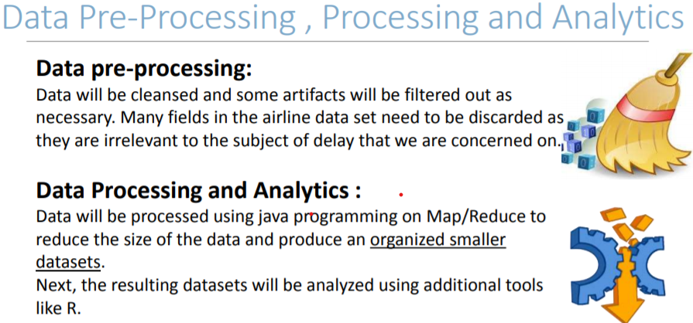

4) Apache Hive
A new table linked with HBase externally is used to
store the outputs generated by Hive queries. The output
of the data is stored in HBase using Insert command for
HBase. There in total 3 different queries performed in
Apache Hive for finding different patterns
Once all the queries are executed, hive includes list of
Tables

5) Apache Pig
Sqoop command is used for loading the data into Pig,
which acts as input data. This data is loaded using
LOAD command on which 2 queries are been performed. The output of the files are stored in both HBase
and HDFS

6) MapReduce
The jar files required for running MapReduce codes
are created using Eclipse. 2 jar files are created using
two different queries in MapReduce for which Top Ten
airlines and Factors Causing details. The output of the
MapReduce program is stored in HDFS.

7) HBase
HBase is used to store the results for the queries.
Initially, tables are created using Create command
All the outputs of Pig and Hive are stored in different
tables of HBase.

8) HDFS
HDFS has been used in the project for storing the results
obtained by running Pig, Hive and MapReduce queries.
The output is stored in .txt format.

9) Data Visualization
The txt files are used for creating different visualization
using Tableau Desktop and Power BI tools.
4.2 TIMELINE CHART

